HEE Nursing and allied health professions recruitment campaign

About our campaign
Overview and aims:
Health Education England, through its Health Careers service, launched a new nursing, midwifery and allied health professions recruitment campaign in May to encourage more 16 to 18 year olds to pursue degrees leading to these careers.
Phase one of the campaign is aimed specifically at those who are going through Clearing in 2018.
The campaign aims to improve perceptions and challenge myths and stereotypes of nursing, the allied health professions and midwifery and to increase applications to relevant undergraduate courses through Clearing in 2018 and potentially UCAS applications in 2019.

Key messages
The campaign will promote a variety of messages about the benefits of studying degrees in these subjects and pursuing careers in these fields. Following audience testing carried out as part of the campaign planning process, the key messages we’ll be communicating through this campaign are:
- Degrees in nursing and allied health professions make you employable – for example 94% of nursing students find a job at the end of their degree
- Degrees in nursing and allied health professions allows you to work anywhere in the country
- Nursing and allied health professions have a purpose and give you the chance to make a difference to people’s lives
These will be supplemented by a variety of secondary key messages eg the opportunities and flexibility these careers offer and being able to work at the forefront of medical technology.

As a university…
We hope you can help us make this campaign a real success.

We would be very grateful for your support in promoting the campaign to your members/partners/students and online followers. We have provided key information about the campaign and how you can support below.

Social media:
The campaign will primarily run through social media, as we believe this will be the most effective way of reaching our target audience, 16 – 18 year olds. This will consist of both social media advertising and non-paid for social media outreach using the assets that have been specifically developed for this campaign.

Our social media activity is being delivered primarily through the Health Careers social media accounts:

Twitter Instagram Facebook

@HealthCareersUK @HealthCareers @healthcareersuk

Ambassadors and campaign assets
We have been in touch with nurses and AHPs from across the country and chosen ambassadors from each of the four fields – child, adult, mental health and learning disability – and a number of priority AHPs.
We have created social media assets for YOU to promote your degree opportunities using your own social media channels.
You can download them all (or those that most interest you) at the links below:

- General nursing
- General AHP
- Adult nursing
- Child nursing
- Learning disability nursing
- Mental health nursing
- Podiatry
- Prosthetics/orthotics
- Speech and language therapy
- Occupational therapy
- Orthoptics
- Operating department practice
- Midwifery
- Therapeutic radiography

Short videos lasting 10-15 seconds featuring some of our ambassadors are also available and can be used as part of your social media activity. If you would like us to send any of these, please email hee.healthcareers@hee.nhs.uk.

How you can help
We would be delighted if you could help us promote the campaign and its key messages with your followers and audiences. There are several ways you could do this:

- Share campaign information on your social media channels, either by sharing tweets/ posts from the Health Careers and Health Education England channels or posting your own messages using the hashtag #KnowAboutNursing or relevant AHP hashtags such as #AHPsintoAction
- Share information about the campaign and campaign assets (such as video and image-led collateral) on your website. This could also include a blog or news piece on your website
- Share information about our campaign in your newsletters and any other communications to organisation members and members of the public

Here are some example social media posts you could use:

General
- We are supporting @HealthCareersUK and @NHS_HEalthEdEng recruitment campaign to challenge myths and stereotypes of careers in nursing and the AHPs. Find out more at http://socsi.in/EJt5j. #KnowAboutNursing #AHPsintoAction

General nursing
- Did you know that at least 94% of nursing students find a job at the end of their degree? Find out more information here http://socsi.in/EJt5jor head over to @HealthCareersUK #KnowAboutNursing #Clearing
- Do you want a career with a purpose where you’ll help people every day? Then you should #KnowAboutNursing Go to @HealthCareersUK or here http://socsi.in/EJt5j to find out more. #Clearing

AHPs
- With an (include relevant AHP) degree, you’ll have great employment prospects and be able to work anywhere in the country. Find out more about becoming an (include relevant AHP) https://bit.ly/2dJxzUC #Clearing
- Thought about a degree in (include relevant AHP)? Get a degree with purpose. Find out more #AHPsintoaction https://bit.ly/2dJxzUC #Clearing

These posts can be edited and revised for relevant professions using the imagery available.

About Health Careers
Health Careers is the information service about the range of 350 or so careers available in health.
It is part of Health Education England (HEE) and our aim is to encourage consideration of health careers and support people in education and at all stages of their career to discover more about the health roles available.
About HEE
HEE supports the delivery of excellent healthcare and health improvement to the patient and public in England by ensuring that the workforce of today and tomorrow has the right numbers, skills, value and behaviours, at the right time and in the right place.

Further information:
For more information on the campaign please contact: HEE@grayling.com or hee.healthcareers@hee.nhs.uk

Examples of campaign assets:
Nursing:
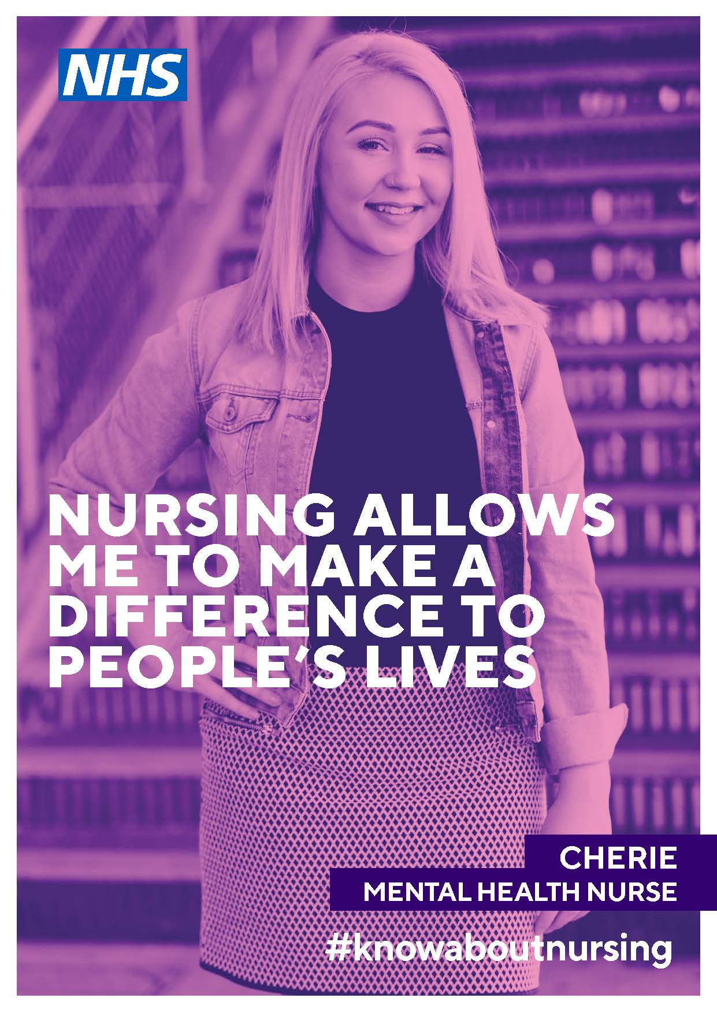

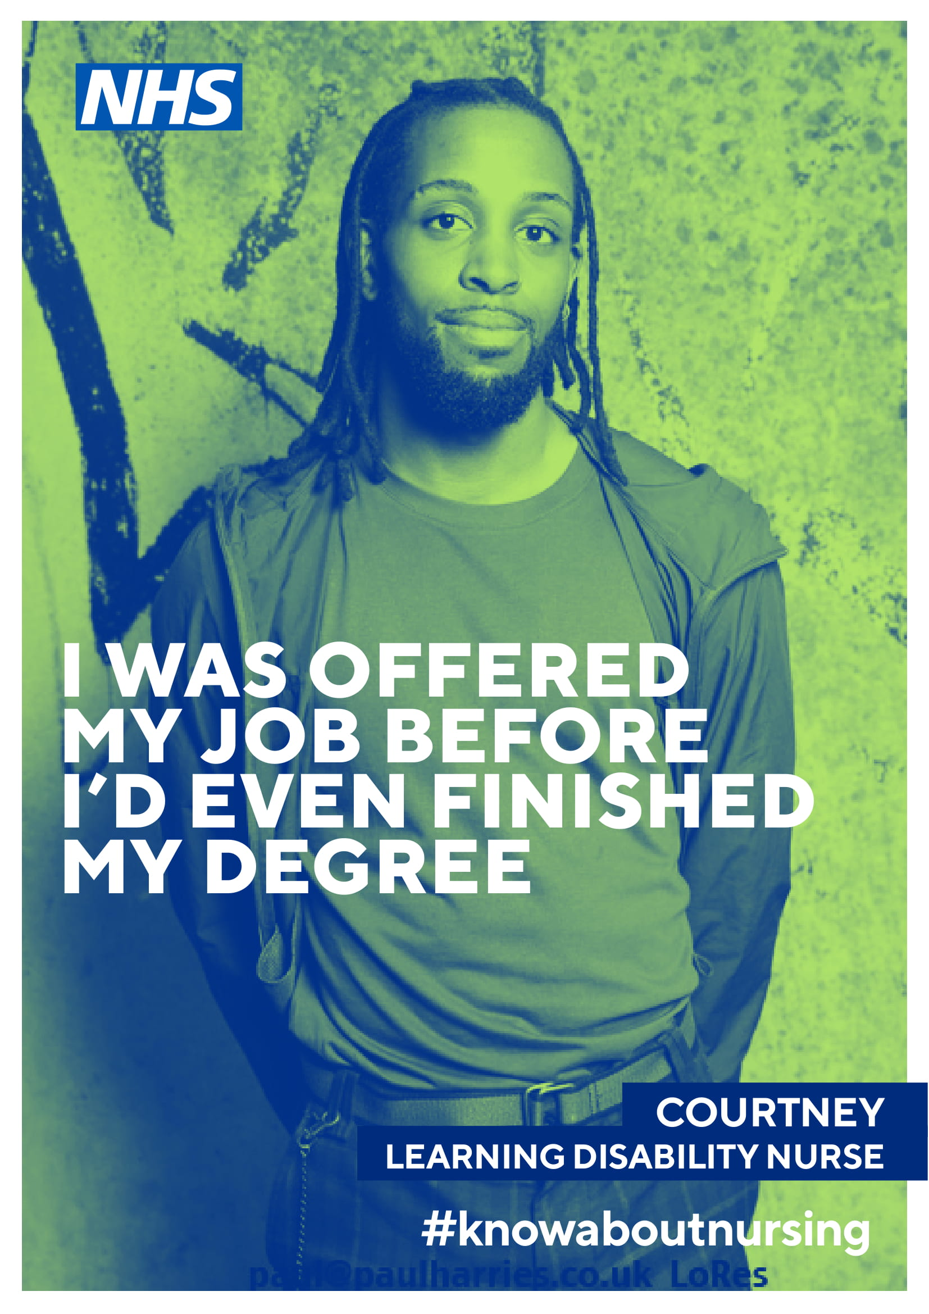
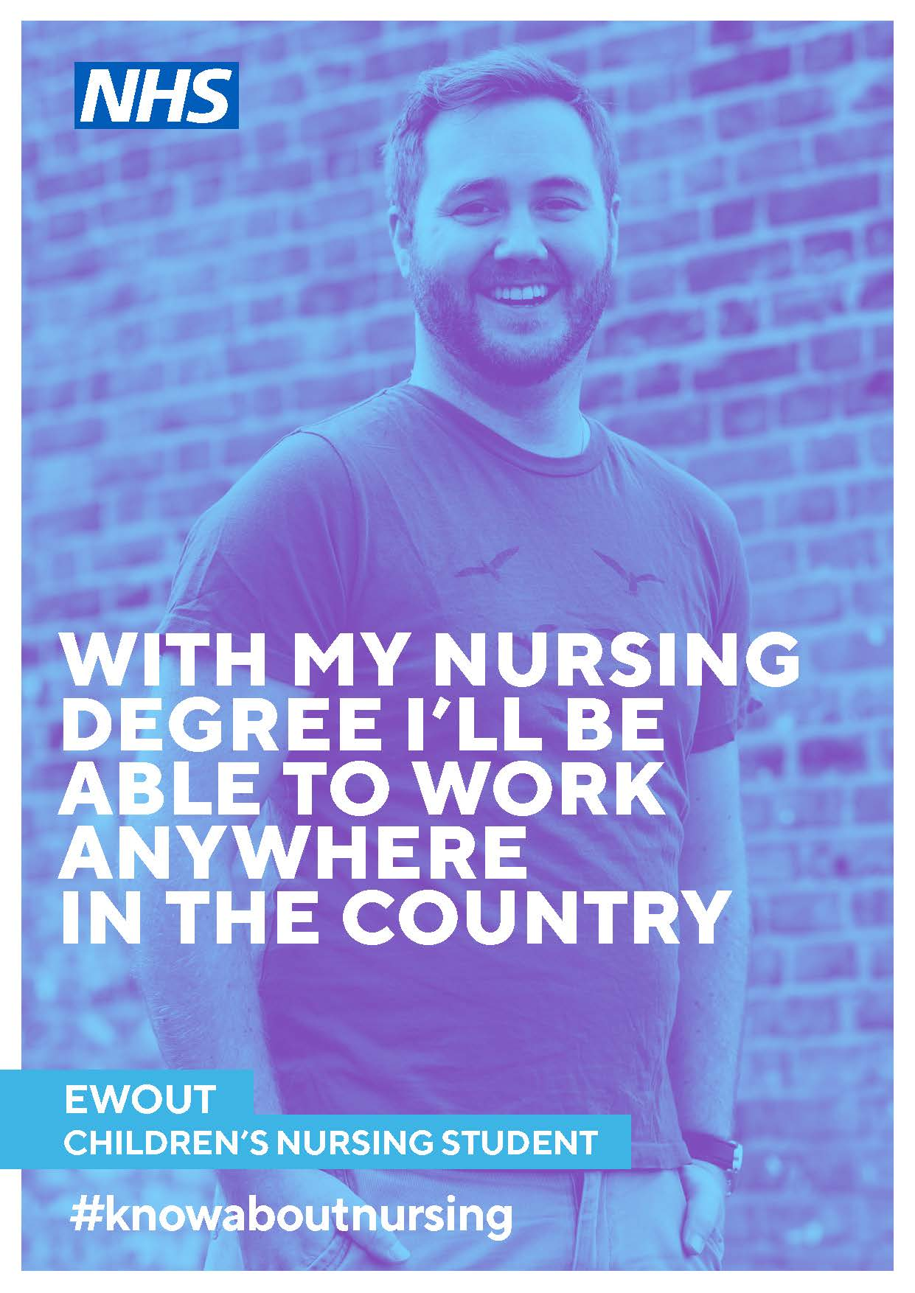
AHPs:
